Middens and Math: “Crashing the Gates” with Florence Hawley Ellis Student Handout

Vocabulary
Archeology: the study of people within the past
Context: where an object was found in the ground including depth and surrounding objects
Artifact: an object made and used by people within the past
Feature: as opposed to portable artifacts, these are the non-portable parts of an archeological site such as walls, hearths, or trash pits
Ethnography: scientific study of people and culture, especially through direct observation
Sequence: timeline of ecological events created by studying tree ring patterns
Midden: trash mound containing layers of artifacts and soil

Introduction: “Women’s Work” in the 19th and 20th Centuries

In 19th- and 20th-century America, gender ideologies governed women’s employment opportunities. Once married, women were supposed to stay home to care for their families while their husbands worked. It was mostly single women therefore who entered the workforce. There, the concepts of “women’s work” and “men’s work” defined the few jobs that were ‘acceptable’ for them to perform. Women were viewed as “too delicate and small for many jobs.” They often became teachers, nurses, or secretaries or worked on a factory assembly line. However, once they married or became pregnant they were often required to quit their jobs. In fact, marriage bar laws enforced from the 1800’s to the 1950’s within certain firms and school boards prevented employers from hiring married women at all. Starting in the mid-19th century, before they even had the right to vote, women started to challenge these ideologies and enter traditionally male-dominated fields.

Women in Archeology
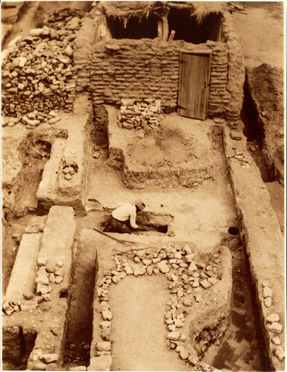 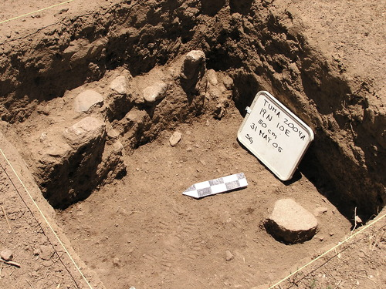Tumacácori National Historical Park, 1935 (left) and 2005 (right) excavations. National Park Service.
Archeology is the study of material culture, such as objects and buildings, to know how people of the past lived. Archeologists divide their time between excavating historic sites, analyzing artifacts in the laboratory, and writing interpretations of their finds. Excavations require long hours spent outdoors performing manual labor. Because of this fact, archeology was traditionally viewed as a “men’s field” and unsuitable for “delicate” women.
Around 1900, women started to “crash the gates” of archeology. At that time, many excavations were carried out in cooperation with the National Park Service. Hearing that “the best way to get into the Park Service is to marry a Ranger,” several of the early NPS women did just that and labored alongside their husbands to preserve park resources as Rangers and archeologists. Some women, like Sallie Pierce Brewer, were referred to as “Honorary Custodians Without Pay.” This meant that even though they and their husbands performed the same work, the wives were not considered NPS employees and did not receive a salary. These women and other early female archeologists helped preserve thousands of archeological resources. However, their work often became overshadowed by that of their well-known husbands. As paid employees, these men were often the ones who led the excavations and whose names were atop the published reports. These factors meant that they, rather than their wives, became the public face of the excavations.

Florence Hawley Ellis
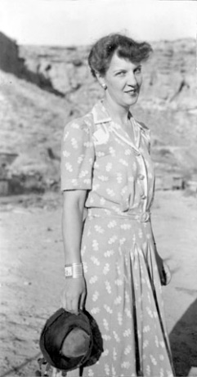
Florence Hawley Ellis at Chaco Canyon in 1940. National Park Service.
Florence Hawley Ellis (1906-1991) was one of these early female archeologists. She was born in Sonora, Mexico and her family moved to Arizona seven years later. Florence would spend the rest of her life in the area studying ancient peoples of the American Southwest and Mesoamerica.
Florence attended college at the University of Arizona, originally planning to study English. However at archeologist Dean Byron Cummings’s suggestion, she enrolled in an archeology course. Eventually she decided to keep her English major but added a minor in anthropology. She graduated in 1927, yet remained at the university and received her Masters degree in anthropology in 1928. In that same year, she began teaching at the school as a professor in the Anthropology department and trained under A.E. Douglass, the pioneer of dendrochronology.
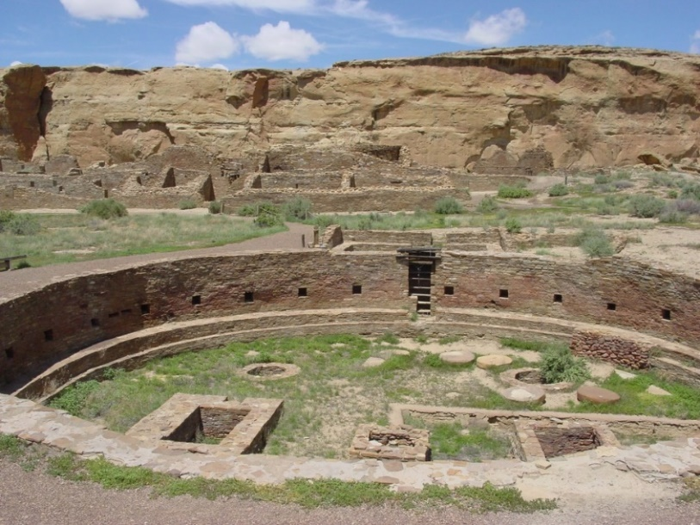Chetro Ketl great kiva at Chaco Canyon. National Park Service.
Starting in 1929, Florence attended the Chaco Canyon National Monument archeological field school run by Edgar L. Hewett, a professor at the University of New Mexico. Hewett was controversial for his time because he allowed, even encouraged, women to attend the field school alongside men. For fifteen seasons between 1929 and 1942, and again in 1947, he taught his students excavation methods and artifact analysis at Chaco. Students lived in tents or hogans (traditional Navajo log structures), were given one gallon of water a day for washing clothes and taking bucket baths, and were dependent on supplies driven in from 100 miles away. Their time was spent excavating the ancient ruins, processing artifacts, visiting the nearby trading post, and attending Navajo ceremonies. Florence took part in 11 out of 15 seasons. As a student, she focused on the Chetro Ketl site, using it for her 1934 dissertation for the University of Chicago. Later on, she became an instructor and used the on-site “museum tent” to train students in artifact analysis. Florence was among the many female archeologists who began their careers at Chaco Canyon.
Florence was involved in many archeological projects throughout her life. In 1936, she published the Field Manual of Southwest Pottery which remained a classic reference text for over fifty years. Along with teaching at Chaco Canyon, she directed archeological field schools at the Spanish mission San Gabriel del Yungue, Sapawe and Tsama Pueblos, Ghost Ranch, and in the Gallina mountains. In the 1950’s, Florence worked on the Wetherill Project at Mesa Verde National Park which was at that time the “largest (archeological) project in the country.”
In the 1960’s and 70’s, she worked with the Indian Land Claims Commission to help define ancient Pueblo and Navajo tribal land boundaries. Throughout her academic career, Florence advocated the use of ethnography within archeological studies. By emphasizing that “human beings made the points and the pottery” that were so often looked at as scientific objects and understanding how these people lived within the past, archeologists could start “[putting] people…back into historic pueblos.”
In 1987, Florence was featured in the Arizona State Museum exhibit “Daughters of the Desert: Women Anthropologists and the Native American Southwest, 1880-1980” along with fellow archeologist Bertha Dutton. The Ghost Ranch Anthropology Museum was named for her, as was the Florence Hawley Ellis Diversity Award given out every four years by the Tree-Ring Society.

Florence’s Methods: Dendrochronology and Statistics

Dendrochronology
During school, Florence studied under A.E. Douglass, the pioneer of dendrochronology. She was among the early scholars who helped develop these techniques and one of the first female archeologists to apply them to historic sites.
Tree rings. National Park Service.

Douglass knew that trees add a light growth ring and a dark sleep ring to their trunks every year. He developed a way to date older and older tree samples by using three principles:

Age
One light growth ring and one dark sleep ring equals one year. By counting the number of rings present within a tree trunk, scientists can know how old the tree is.

Environmental Patterns
The growth ring width is determined by environmental conditions. For example, a rainy season will result in a wide growth ring while a drought will cause a thin one. Using the number of tree rings and the width of each one, scientists can create a timeline, or sequence, of ecological events. By overlapping the sequences from older and older trees, scientists can create a master sequence for a region that goes back thousands of years.

Cross-dating
By matching the patterns of tree rings within unknown dates to this master sequence, scientists can identify when the undated tree died naturally or was cut down. Archeologists use this methodology to date the artifacts and buildings they uncover on sites. For example, if the oldest post within a building is from a tree cut down in 1700, archeologists know that the building must have been erected after that date.

Cross-dating of tree rings. National Park Service.

When asked if it was her own idea to apply these methods at Chaco Canyon, Florence replied, “You bet it was!” For her 1934 dissertation, she analyzed hundreds of wood and charcoal samples from Chetro Ketl, making it “the best dated ruin at Chaco” at that time.
She continued utilizing dendrochronology over the course of her career. In 1934, she and other archeologists began a six-year project to establish tree sequences for areas within the central United States. Archeologists and members of the public from around the country sent hundreds of wood samples from sawmills, forest stumps, historic structures, and many other sources to the University of Chicago laboratory for analysis. The results were “Master Charts” for sampled tree species, one of which reached back to 1500. This project was up until then the largest dendrochronological study performed and, while tedious, provided a valuable reference for future archeologists seeking to date ancient American sites.

Statistics
“It was not my new application of the formula for statistically significant differences in evaluating percentage variations of pottery types in successive levels of a deep dump at Chetro Ketl which brought the recognition. It was the dendrochronology. Tree ring dating was adjudged a proper science. Anthropology, with the exception of physical anthropology was not.”
At Chetro Ketl, the excavation team uncovered a midden, or trash mound, that contained layers of soil and artifacts that had built up over time. Florence noticed that the midden contained many different styles of pottery. She wished to know how these decoration patterns changed over time. Her method was simple yet groundbreaking.
Florence first used statistics to understand how the amounts of each pottery type differed between the midden layers. She then used bits of charcoal found within the layers to date each one. Using this method, she could know how the ancient Chacoans changed their pottery decorations and exactly when they did so. Her work was “one of the earliest uses of form statistics…in American archeology” and was termed “a milestone” in archeological analysis.
Florence’s illustration of the Chaco midden layers. Featured in her dissertation “The Significance of the Dated Prehistory of Chetro Ketl, Chaco Canyon, New Mexico.”

Activity: Archeological Excavation
Imagine that you are an archeologist excavating a midden on a historic site. You are finding charcoal and pottery sherds in the layers. Use Florence’s methods to interpret your finds.

Step 1) You find a piece of charcoal in one of the layers. When you examine it under a microscope, you see this sequence of vertical growth rings.
Tree rings sequence. National Park Service.

Count the number of light growth rings. How old is this sample? Looking at the width of these rings, are there any years that were very wet? Very dry?

Step 2) While excavating, you find ceramic pieces with these four decorations:
Ceramic decorations. National Park Service.

Describe each of these decoration styles. How are they similar? How do they differ? What might these similarities and differences mean?
Step 3) The vessels above could have been made by people who lived at Chaco. They could also have been made in other villages and been traded for Chacoan goods. Over time, these two types of vessels got broken and mixed together within the midden.
Your research shows that the white-and-black pottery you found was made at Chaco and the red-and-black pottery was a trade item made elsewhere.
You have dated the midden layers using your charcoal analysis and counted the number of local and traded pottery types within each. Use the graphs to answer the questions below.

Graph 1: Local versus non-local pottery types. National Park Service.

Midden Layer Date | Number of Locally-Made Sherds | Number of Non-Locally-Made Sherds
1000 CE | 1 | 6
1050 CE | 2 | 9
1100 CE | 5 | 7
1150 CE | 7 | 5
1200 CE | 11 | 1
Data table for Graph 1: Local and non-local pottery types. National Park Service.

Did the number of ceramics made at the site increase or decrease over time? What about those made elsewhere?
Describe the patterns you see. Does the number of local ceramics seem to influence that of non-local ones? What might this mean? Could this pattern tell you anything about the availability of local resources? Environmental conditions?

Step 4) Compare the results of Graph 1 with Graph 2 below.

Midden Layer Date | Number of Locally-Made Sherds | Number of Non-Locally-Made Sherds
1000 CE | 1 | 2
1050 CE | 2 | 9
1100 CE | 5 | 3
1150 CE | 7 | 6
1200 CE | 7 | 10
Graph 2: Local versus non-local pottery types. National Park Service.
National Park Service.

Data table for Graph 2: Local and non-local pottery types. National Park Service.

Do the patterns in this graph differ? How does this change your interpretation of the site?

Mandelson, Dayle A. “Women’s Changing Labor-Force Participation in the United States,” in Women and Work: A Handbook, eds. Paula J Dubeck and Kathryn Borman, 6.
Mandelson, Dayle, “Women’s Changing Labor-Force Participation,” 6.
Martelle Trager, as quoted in Kaufman, Polly Welts, Natural Parks and the Women’s Voice: A History, University of New Mexico Press, 1996, 87.
Ruth Ashton Nelson, as quoted in Natural Parks and the Women’s Voice: A History, 87.
Kaufman, Women’s Voice, 86.
Joiner, Carol. “The Boys and Girls of Summer: The University of New Mexico Archeological Field School in Chaco Canyon,” in Journal of Anthropological Research, vol. 48, no. 1. Spring 1992, 56; Kaufman, Polly Welts. National Parks and the Woman’s Voice: A History, University of New Mexico Press, 1996, 84.
Joiner, “Boys and Girls,” 52.
Joiner, “Boys and Girls,” 52.
Irwin-Williams, “Women in the Field,”24; Kaufman, Women’s Voice, 84.
“Biographical Sketch.” Florence Hawley Ellis Papers. University of New Mexico. 17 June 2015. URL: http://www.unm.edu/~toh/fhe/bio.html.
Kaufman, Women’s Voice, 164.
Irwin-Williams, “Women in the Field,” 24.
Ellis, Florence Hawley. “Across Some Decades.” In Ethnohistory, Fall 1971, vol. 18, no. 4, 304.
Joiner, “Boys and Girls,” 57.
Kaufman, Women’s Voice, 84.
Hawley, Florence. Tree Ring Analysis and Dating in the Mississippi Drainage. University of Chicago Press, 1941.
Hawley, Tree Ring Analysis, 69.
Hawley, Tree Ring Analysis, 69.
Ellis, “Across Some Decades,” 296.
Irwin-Williams, “Women in the Field,” 23.

